Progression with separate trees for ship slots, pilot slots, and upgrades.

Two resources:

* Credits (shared)
  + Start game with 1000Cr per player

Acquisition:

* Bounties for enemy pilots (elite)
* Contract completion
* Basic income (per pilot per Rotation(Equivalent of a ‘Day’ in *PMD.* (can complete any number of menial tasks then do 1 mission. WorldState refreshes after a ‘Day’, resetting things like mission boards and shops)))

Uses:

* See *Hanger Progression* and S*hip Progression*
* Experience (individual)

Acquisition:

* See morgan’s playtest (Image01)

Uses:

* Pilot card abilities (limited or non-limited (player discretion))
  + While a pilot ability is slotted, ship counts as limited
* Initiative (max 6)
* Talent upgrades (non-limited)
* Force upgrades (non-limited)
* Force charges (max 3)
* Slot progression styled a bit like flight group alpha (Different specialized paths) (Image02)

Mission Rewards  
 Experience

Credits

Reputation gain/loss  
 Special rewards (ships, upgrades, etc.)

Player Progression

Rank 0: Choose Species

* Biological
* Droid
  + Focus becomes Calculate
  + While you perform a white Calculate action, you may treat it as red to gain 1 additional calculate token.

Rank 1: Choose Path

Paths allow taking upgrades normally not allowed.

Hangar progression (Shared)

* Contain all owned ships. Starts with one ship bay per player. Ships are shared between the players.
* Purchase additional bays for more ship types.
  + Cost per bay = (base cost) \* fibonacci[n] where n is number of bays acquired beyond the starting bays
* Purchase tools allowing increased modification of ships
  + Specific tools per ship
  + Specific tools per tier allowing modification of higher tiers
* Repair damage from ships
  + Able to purchase upgrades that reduce repair costs for specific ships
* Purchase new ships
* Purchase upgrades to be stored on site. A ship's equipped upgrades may be swapped for other upgrades on site whenever its the hanger (takes time per upgrade swapped).

Ship Progression (Specific)

* Install new slots (Add mod slots, secondary weapons, etc.)
  + Mod slots allow adding stats without drawbacks (3 max modification slots)
  + 8 non-pilot slots max per ship

Ship Progression

Access to tiers of ship (each tier requires purchasing the equivalent level of military hardware licence)

Configuration slot is considered part of the chassis, not an upgrade slot

Title is a unique chassis, not an upgrade slot

Crew: Access to all Scum and Villainy, one time cost

Other factions: Higher base price, upkeep cost each mission

Ship Upgrade Slot Capacities:

* Ship chassis have their default upgrade slots minus title slots. Any talent slots are replaced with modification slots.
* A ship can have modification and illicit slots grafted onto it while it is in the hangar. A ship can have a max of 3 modification slots and 2 illicit slots.

Custom Stuff

* Play as Droid (Focus replaced by Calculate, other possible changes)
* Distinction between *ship* actions and *pilot* actions. Ship actions (like target lock) are tied to the chassis, whereas pilot actions are tied to the pilot (like focus).
* Job Payout
  + Reputation
    - Increased reputation for faction posting job
      * Base increase by 1
    - Decreased reputation for faction job is against
      * Base decrease by 1
  + Experience
    - Bonus reward specified by some missions
  + Credits
    - Higher risk missions may incur more damage, but will have higher rewards. Special rewards, increased experience, etc.
    - Titled ships only as special rewards
* A ship can be disabled by ionizing it while it has 0 shields and 2 or less hull remaining
* Pilot eject rolls
  + Friendly Territory
    - Roll 1 attack die
  + Neutral Territory
    - Roll 2 attack dice
  + Enemy Territory
    - Roll 3 attack dice
  + Blank (Safe eject): No effect
  + Eye (Concussion): Lose 2 experience per eye
  + Hit (Wounded): Lose 3 experience and 400 credits per hit (healing cost)
  + Crit (Severely wounded): Lose 5 experience, Permanent debuff
  + Double Crit (KIA): Pilot dies. Start a new character with 0 experience, do not receive starting cash infusion.
  + Experience total can go negative
* Severe Injuries
  + Focus and calculate are always red
  + Focus only modifies one die (Bio-only)
  + Roll 1 fewer die for hyperspace rolls (Droid-only)
  + Cannot modify hyperspace rolls
  + Repositions are always red.
  + After you perform an action, roll 1 attack die. On a hit or crit result, gain 1 stress token.
  + Start each mission with 2 stress tokens.
  + After you execute a maneuver, if you overlapped an obstacle, suffer 1 damage.
  + Increase difficulty of turn maneuvers.
* Failure state
  + If all pilots are dead
  + If there are not enough ships for all pilots to fly in a mission
* (Future goal): Salvage
  + Parts
  + Ships
  + Etc.

Images:

Image01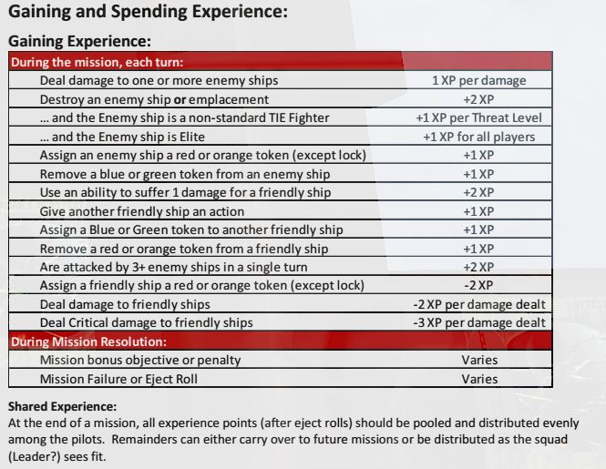

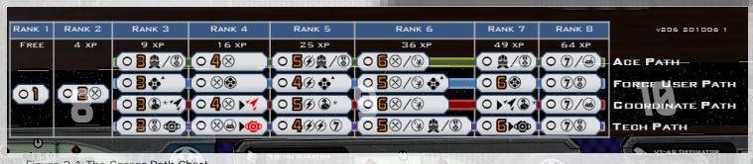

Image02